Phishing Simulation & Security Awareness Report
Author: Favour Omachi
Tools Used: GoPhish, Gmail SMTP, Browser Header analysis.

Table of Contents
1. Executive Summary 3
2. Objective 3
3. Methodology & Campaign Setup 4
3.1 Environment 4
3.2 Email Template 4
3.3 Tracking Mechanism 4
4. Campaign Results 4
5. Technical Analysis: Email Header Forensics 5
6. Attack Sophistication Analysis 7
7. Defensive Recommendations 7
7.1 Technical Controls 7
7.2 Human Controls 8
8. Reflection 8
9. Tools & References 9

1. Executive Summary
This report documents a self-directed phishing simulation conducted as a portfolio project to develop practical knowledge of how phishing campaigns operate at a technical level. The simulation was carried out against the author's own email account in a controlled environment with no third parties involved.
The exercise used GoPhish, an open-source phishing framework widely used by enterprise red teams and security awareness professionals to build, send, and track a simulated credential-harvesting email campaign. The phishing email impersonated a corporate IT department and directed the target to a cloned Microsoft 365 login page.
Prior to this exercise, the author assumed phishing attacks were manually crafted and individually sent by attackers. This project revealed the reality: modern phishing operations use automated kits, campaign management dashboards, per-recipient tracking, and cloned legitimate login pages, lowering the technical barrier for attackers significantly while dramatically increasing scale and success rates.

Key outcomes of the simulation:
- A convincing phishing email was successfully delivered to the target inbox.
- A cloned Microsoft 365 login page was generated automatically using GoPhish's site importer.
- Email open and link click events were tracked per recipient using hidden tracking pixels and unique URL parameters.
- Email header analysis revealed five distinct technical indicators that a trained analyst would use to identify the email as fraudulent.

2. Objective
The objective of this project was threefold:
- Understand how phishing campaigns work at a technical level and not just conceptually, but by building and running one end-to-end.
- Learn to read and interpret email headers as a first step in phishing email forensics.
- Produce a professional security awareness report that could be delivered to non-technical staff or a CISO, demonstrating the ability to communicate risk clearly.

3. Methodology & Campaign Setup

3.1 Environment
- Platform: GoPhish v0.12 running locally on macOS
- Mail relay: Gmail SMTP with App Password authentication
- Target: Personal email address (self-contained test)
- Landing page: Cloned from login.microsoftonline.com using GoPhish's built-in site importer.

3.2 Email Template
The phishing email was designed to impersonate a corporate IT security team. Key social engineering elements included:
- Urgency trigger: subject line stating password expiry within 24 hours.
- Authority signal: sent from a plausible IT support address (ITsupport@maltina.com).
- Fear of consequence: explicit warning that failure to act would result in account suspension.
- Single clear call to action: a prominently styled blue button labelled 'Reset My Password Now’.
- Legitimacy signal: 'Do not reply to this email' footer mimicking automated corporate communications.

3.3 Tracking Mechanism
GoPhish automatically embedded two tracking mechanisms into the campaign:
- Tracking pixel: a hidden 1x1 pixel image whose URL included a unique recipient ID. When the email client loaded the image, GoPhish recorded an 'Email Opened' event with a timestamp. This is identical to the mechanism used in all commercial email marketing platforms.
- Tracked URL: the call-to-action button linked to the GoPhish server with a unique rid= parameter. Clicking the button recorded a 'Clicked Link' event before redirecting the target to the cloned login page.

4. Campaign Results
Event | Outcome
Email Sent | ✓ Successfully delivered to inbox
Email Opened | ✓ Recorded via tracking pixel
Link Clicked | ✓ Recorded via unique rid= parameter
Credentials Submitted | ✓ Cloned login page loaded successfully
Post-click redirect | ✓ Redirected to real Microsoft site

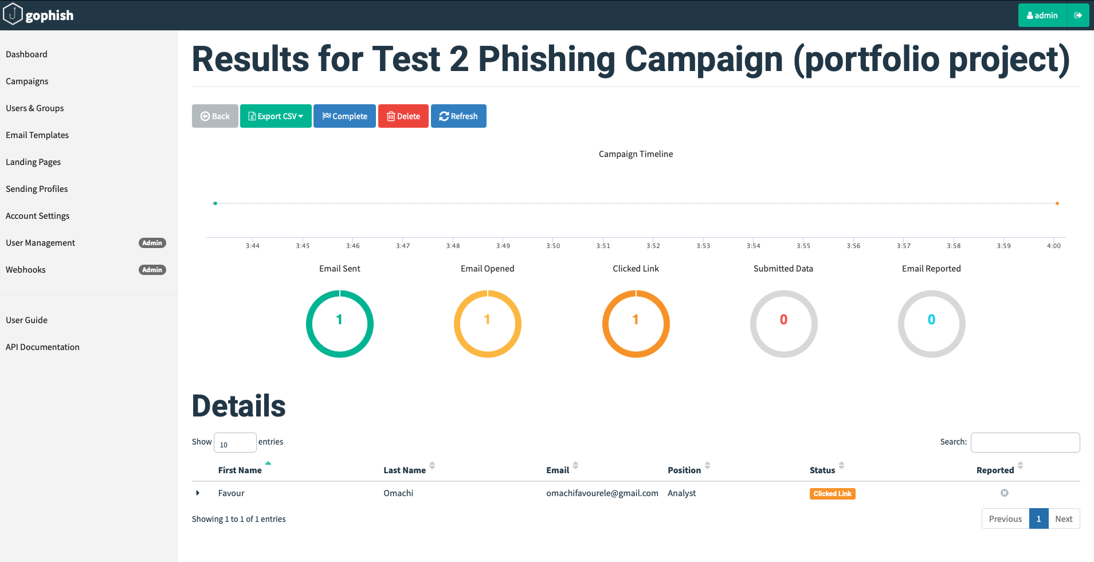
Campaign Results

5. Technical Analysis: Email Header Forensics
Selecting 'Show Original' in Gmail exposes the full email header which includes metadata invisible to the recipient that records the complete technical journey and origin of the email. Below are five findings from the header analysis of the simulated phishing email.

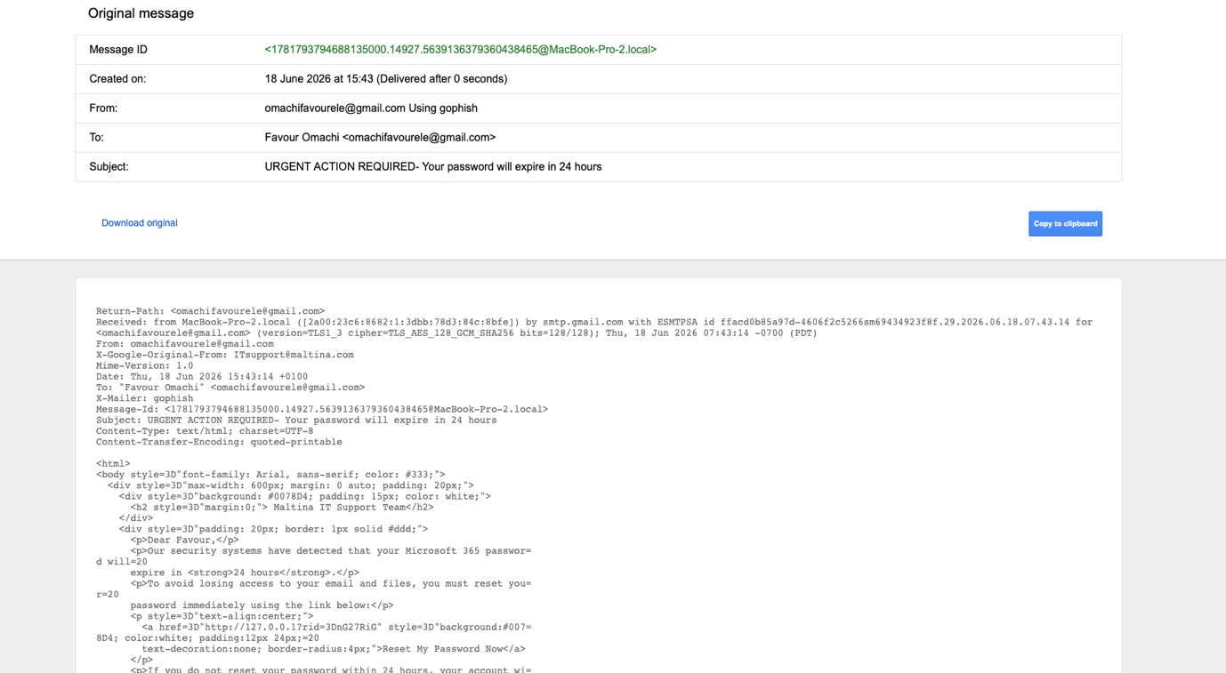
Raw header text: “Show original” on Gmail result

Finding 1: Return-Path Exposes Real Sending Address
Header Evidence | Return-Path: <omachifavourele@gmail.com>
Explanation | The Return-Path header reveals where bounced emails are sent and therefore the genuine sending address. Despite the email displaying a corporate IT address in the visible From field, the Return-Path exposes the real Gmail account used to send it. A trained analyst checking this field immediately identifies the mismatch.
Severity | HIGH
Real-World Risk | In a real attack, this address would belong to an attacker-controlled domain. Defenders should train analysts to compare Return-Path against the display from address as a first-line phishing check.

Finding 2: Display Name Spoofing via X-Google-Original-From
Header Evidence | From: omachifavourele@gmail.com X-Google-Original-From: ITsupport@maltina.com
Explanation | GoPhish instructed Gmail to send the email as ITsupport@maltina.com. Gmail intercepted this attempt and recorded both addresses: the attempted spoofed address in X-Google-Original-From and the real sending address in From. This header pair is the clearest evidence of display name spoofing. On a mail server without Gmail's protections, only the fake address would appear.
Severity | HIGH
Real-World Risk | Attackers using their own mail servers avoid this exposure entirely. Organisations should enforce DMARC policies that reject emails where the from domain does not match authenticated sending infrastructure.

Finding 3: Hidden Tracking Pixel for Open Detection
Header Evidence | <img alt="" style="display:none" src="http://127.0.0.1/track?rid=nG27RiG"/>
Explanation | GoPhish automatically injected a hidden 1x1 pixel image into the email body. The moment the recipient's email client loaded the email, it attempted to fetch this image from the GoPhish server recording an Email Opened event with a timestamp and the recipient's IP address. The rid=nG27RiG parameter uniquely identifies the recipient. This mechanism is identical to that used in commercial marketing emails and is the standard method for tracking email open rates.
Severity | MEDIUM
Real-World Risk | Disabling automatic image loading in email clients prevents tracking pixel activation. Enterprise email gateways can be configured to strip tracking pixels. Users should be trained to check for this in suspicious emails.

Finding 4: X-Mailer Header Not Properly Spoofed
Header Evidence | X-Mailer: gophish
Explanation | The email template specified X-Mailer: Microsoft Outlook 16.0 to make the email appear sent from Outlook. However, GoPhish overrode this with its own identifier — 'gophish'. Enterprise email security tools and SIEM detection rules specifically flag the string 'gophish' in X-Mailer headers, as it is a known indicator of a phishing simulation or attack tool. A real attacker would ensure this header is properly overridden.
Severity | LOW
Real-World Risk | This represents a detection opportunity for defenders. SIEM rules should alert on known phishing framework identifiers in X-Mailer headers. The presence of 'gophish' in a production environment would indicate either an authorised simulation or a threat actor using the same tooling.

Finding 5: Personalised Tracking URL with Recipient ID
Header Evidence | href="http://127.0.0.1?rid=nG27RiG"
Explanation | The call-to-action button embedded a unique recipient identifier in the URL. When clicked, GoPhish logged which specific recipient clicked the link, the timestamp, and their browser and IP information — before redirecting them to the cloned login page. This per-recipient tracking enables attackers to build detailed profiles of which targets engaged with a campaign, informing follow-up attacks.
Severity | HIGH
Real-World Risk | URL inspection before clicking is a key user behaviour to train. Security awareness programmes should teach recipients to hover over links to preview the destination URL, and to treat any URL containing unusual parameters with suspicion.

6. Attack Sophistication Analysis
Reflecting on the simulation, the following factors limited the realism of this phishing email. A more sophisticated attacker would address each of these:

- Lookalike domain registration: The most significant giveaway was the sending address. A real attacker would register a domain such as maltina-itsupport.com or m4ltina.com and configure it with valid SPF, DKIM, and DMARC records meaning the email would pass all authentication checks and the return path would show a plausible address. Gmail would not expose an X-Google-Original-From header because there would be no spoofing attempt.
- Dedicated mail relay: Using a personal Gmail account meant Gmail's own protections partially exposed the spoofed sender. A dedicated SMTP relay with a properly configured sending domain bypasses these protections entirely.
- HTTPS landing page: The cloned login page ran on http://127.0.0.1 — a local address with no HTTPS padlock. A real attacker would host this on a cloud server with a free Let's Encrypt SSL certificate, making the padlock appear and significantly increasing victim confidence.
- Target personalisation: The more detail an attacker knows about a target (their manager's name, current projects, recent company announcements), the more convincing the email. Spear phishing using personal details achieves significantly higher click rates than generic campaigns.

7. Defensive Recommendations
The following controls would reduce the risk and impact of a phishing campaign of this type against an organisation:

7.1 Technical Controls
- Enforce DMARC with a reject policy (p=reject): DMARC instructs receiving mail servers to reject emails that fail SPF and DKIM authentication. This is the single most effective technical control against email spoofing. Many organisations have DMARC in monitoring mode (p=none) but have not moved to enforcement.
- Deploy an email security gateway: Products such as Proofpoint, Mimecast, or Microsoft Defender for Office 365 scan inbound emails for phishing indicators including known phishing kit signatures, lookalike domains, and suspicious header combinations before they reach the user's inbox.
- Enforce multi-factor authentication (MFA): Even if credentials are captured on a phishing landing page, MFA prevents an attacker from using them without also possessing the second factor. This is the most important control for limiting the impact of a successful credential harvest.
- Disable automatic image loading in email clients: This prevents tracking pixel activation, denying the attacker confirmation that an email was opened and removing a source of recipient intelligence.

7.2 Human Controls
- Verify sender addresses carefully: Users should be trained to check not just the display name but the actual email address and to look for lookalike domains (maltin4.com vs maltina.com). Where possible, show full email addresses rather than display names in the email client.
- Inspect links before clicking: Hovering over a link reveals the true destination URL. Users should be suspicious of any link whose domain does not match the organisation it claims to be from.
- Use 'Show Original' for suspicious emails: Teaching users to view email headers demystifies the technical layer and enables even non-technical staff to spot Return-Path mismatches and authentication failures.
- Run regular phishing simulations: Organisations should conduct periodic simulated phishing campaigns as performed in this project to measure click rates, identify high-risk teams, and deliver targeted training to those who engage with simulated phishing emails.
- Establish a clear reporting process: Users who suspect a phishing email should know exactly how to report it; a dedicated security@ email address, a one-click Outlook/Gmail plugin, or a Slack channel. The easier reporting is, the more likely users are to do it.

8. Reflection
Before conducting this simulation, I understood phishing conceptually, I knew it involved deceptive emails designed to steal credentials. What I did not appreciate was the degree to which modern phishing is industrialised. GoPhish provides a campaign management dashboard, per-recipient tracking, automated site cloning, and detailed analytics functionally identical to a commercial email marketing platform, but weaponised. The barrier to entry for a phishing attacker is far lower than I assumed.

The most surprising discovery was email headers. The fact that every email carries a detailed technical audit trail recording the true sending address, the servers it passed through, authentication results, and even the software used to send it was not something I was aware of before this project. The 'Show Original' function has been present in Gmail throughout my entire time using it. This experience underscored how much security-relevant information exists in everyday tools that most users, including myself, have never examined.

This project has direct relevance to my professional experience. During my placement year at The Walt Disney Company, I was involved in delivering security awareness training to staff. Having now built and run a simulation end-to-end at a technical level, I have a significantly deeper understanding of both the attacker's methodology and the technical indicators that defenders and end users should be trained to recognise.

The gap I identified in my own simulation the exposed X-Google-Original-From header and the X-Mailer: gophish string illustrates that even automated phishing tools leave detectable traces. Effective defence combines technical controls that catch these traces automatically with human training that equips users to spot what technology misses.

9. Tools & References
- GoPhish- open-source phishing framework: getgophish.com
- MITRE ATT&CK T1566- Phishing: attack.mitre.org/techniques/T1566
- NCSC guidance on DMARC: ncsc.gov.uk/collection/email-security-and-anti-spoofing
- Google- Understanding email headers: support.google.com
- NIST SP 800-177-Trustworthy Email: csrc.nist.gov

Appendix
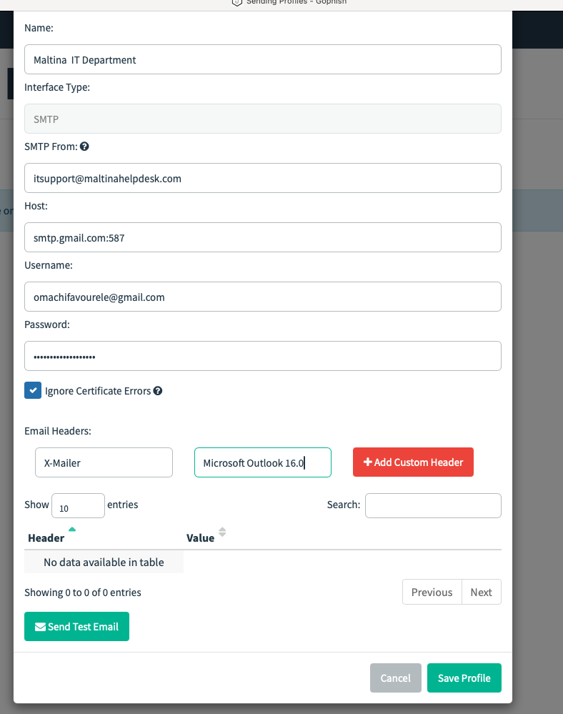

Setting up a profile on GoPhish

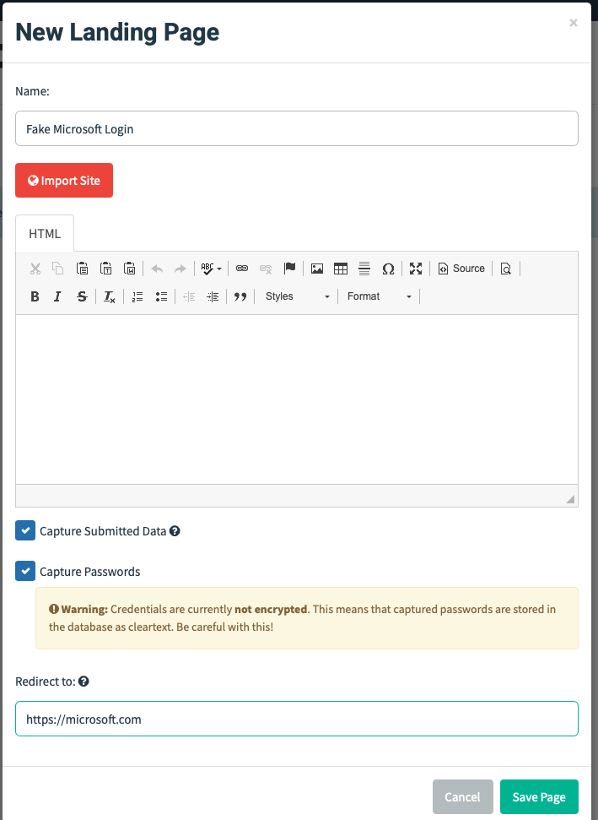
Redirecting the recipient to the Microsoft login page for credential harvesting, utilising the GoPhish feature to import the legitimate Microsoft site.

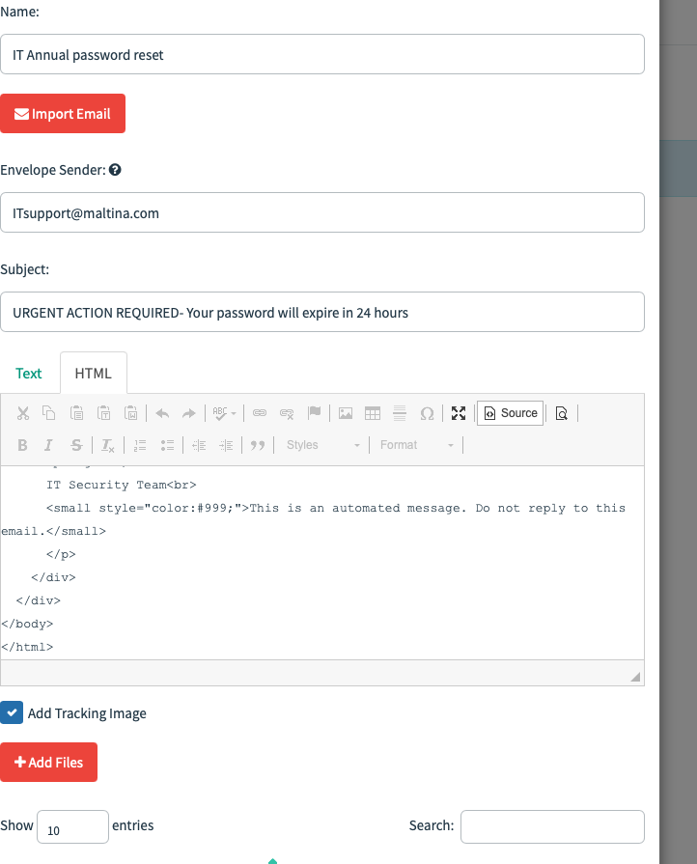
Drafting the “phish” email
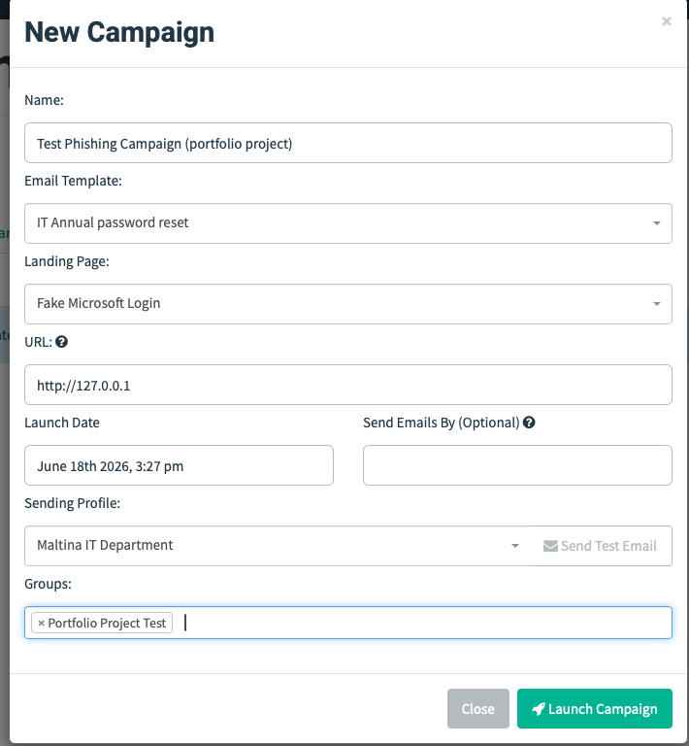
Setting up campaign

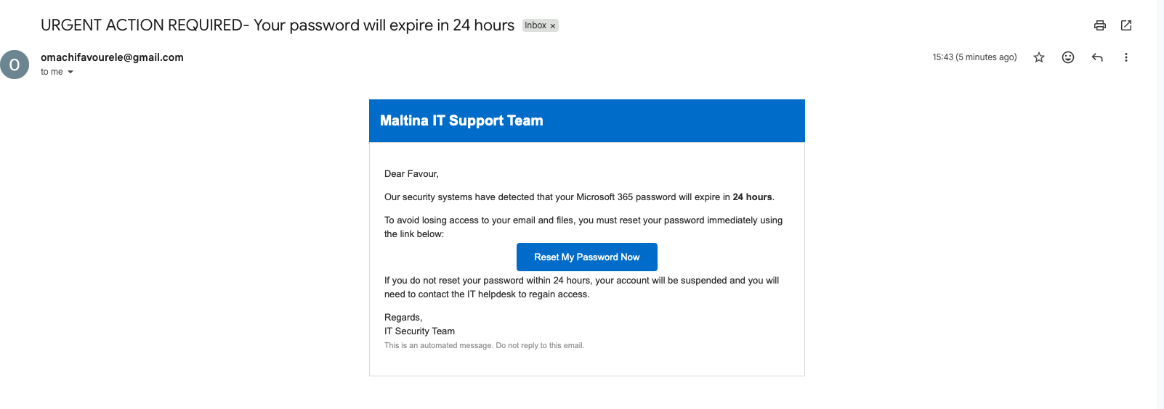

Received phishing email in my inbox

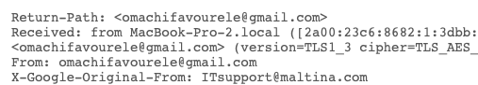
Google masking the original from field(sender)

Screenshot showcases the Server the email came from (Gmail)

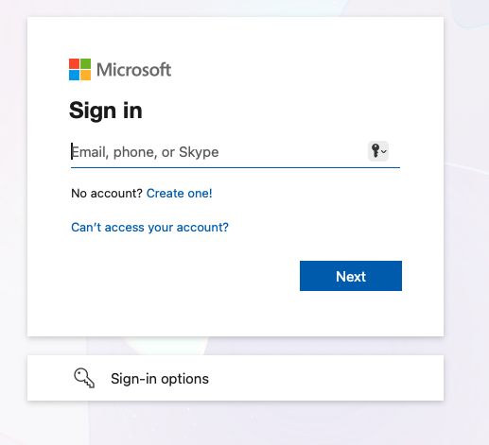
Redirected to Microsoft sign-in

